Practical 2 – Web Based Application

Q1) In this exercise, you add a TextBox, a Label, and a Button control to a page. When you request the page in the browser, these server controls are transformed into HTML, that is then sent to the client. By looking at the final HTML for the page in the browser, you’ll see how the HTML is completely different from the initial ASP.NET markup.

- Start Visual Studio and create a new web site.
- Create a new Web Form called ControlsDemo.aspx. Choose your programming language and make sure the Web Form uses Code Behind.
- Switch to Design View. From the Standard category of the Toolbox, drag a TextBox, a Button, and a Label control onto the design surface within the dashed lines of the <div> tag that was added for you when you created the page.

Type the text Your name in front of the TextBox and add a line break between the Button and the Label by positioning your cursor between the two controls in Design View and then pressing Enter. If you’re having trouble positioning the cursor between the controls, place it after the Label control and then press the left arrow key twice. The first time you press it, the Label is selected; the second time, the cursor is placed between the two controls, enabling you to press Enter. Your Design View should now look like Figure 1.

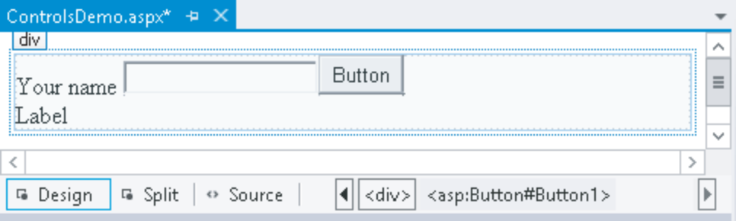
Figure 1

Right-click the Button control and choose Properties to open up the Properties Grid for the control. Pressing F4 after selecting the Button does the same thing. The window that appears, shown in Figure 2, enables you to change the properties for the control, which in turn influences the way the control looks and behaves at run time.

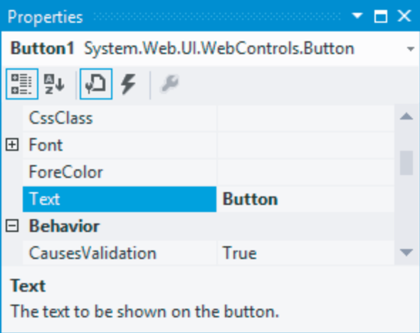
Figure 2

- Set the control’s Text property to Submit Information and set its ID (which you’ll find all the way down at the bottom of the list wrapped in parentheses) to SubmitButton.
- Change the ID of the TextBox to YourName using the Properties Grid.

- Clear the Text property of the Label using the Properties Grid. You can right-click the property’s label in the grid and choose Reset, or you can remove the text manually. Set its ID to Result.
- Still in Design View, double-click the Button control to have VS add some code to the Code Behind of the page that will be fi red when the button is clicked in the browser. You see later how to accomplish the same thing from Markup View. Add the bolded line of code to the code block that VS inserted for you:

Protected Sub SubmitButton_Click(sender As Object, e As EventArgs) Handles SubmitButton.Click
Result.Text = "Your name is " & YourName.Text
End Sub

Note that the VB.NET example doesn’t need an underscore here to split the code over two lines. In older versions of VB.NET, the underscore was required to split this code over two lines.

- Save the changes to the page and then open it in the browser by pressing Ctrl+F5. Don’t click the button yet, but open up the source of the page by right-clicking the page in the browser and choosing View Source or View Page Source. You should see the following HTML code (I changed the formatting slightly so the HTML fits on the page):

<div>
Your name <input name="YourName" type="text" id="YourName" />
<input type="submit" name="SubmitButton" value="Submit Information"
id="SubmitButton" />
<br />
<span id="Result"></span>
</div>

- Switch back to your browser, fill in your name in the text box, and click the button. When the page is done reloading, open up the source for the page in the browser again using the browser’s rightclick menu. The code should now look like this:

<div>
Your name <input name="YourName" type="text" value="Imar" id="YourName" />
<input type="submit" name="SubmitButton" value="Submit Information"
id="SubmitButton" />
<br />
<span id="Result">Your name is Imar</span>
</div>

Q2) In this exercise you see how to use the Panel control as a container for some simple text. In addition, you use a CheckBox to control the visibility of the Panel at the server.

- Start by creating a new Web Form with Code Behind called Containers.aspx.
- Switch the page into Design View and drag a CheckBox and a Panel control from the Toolbox on the design surface into the dashed <div> element.
- Give the CheckBox control a meaningful description by setting its Text property to Show Panel and set its AutoPostBack property to True using the Properties Grid. Rather than choosing True from the drop-down list for the property, you can also double-click the AutoPostBack property or its value to toggle between False and True.
- Set the Visible property of the Panel control to False using the Properties Grid. This hides the Panel control when the page first loads.
- Inside the Panel control, type some text (for example, I am visible now). Note that the panel behaves like the rest of VS’s design surface. You can simply add text to it, select and format it, and add new controls to it by dragging them from the Toolbox. The code for the panel should end up like this in Markup View:

<asp:Panel ID="Panel1" runat="server" Visible="False">
I am visible now
</asp:Panel>

- If necessary, switch to Markup View and locate the code for the CheckBox. Position your cursor right before the closing forward slash (/) and type On, followed by Ctrl+Space. This brings up IntelliSense, as shown in Figure 3.
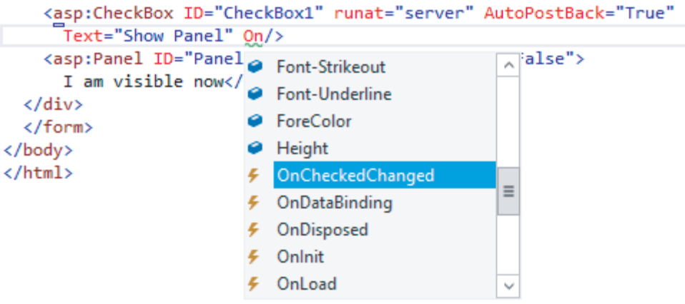
Figure 3

Select OnCheckChanged by pressing Tab or Enter. Next, type an equals sign (=), which brings up IntelliSense again as shown in Figure 4.

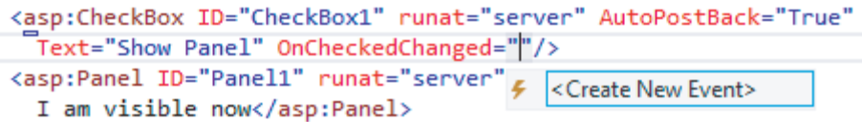
Figure 4

Select the <Create New Event> item and press Tab. VS completes the code as follows: OnCheckedChanged="CheckBox1_CheckedChanged"

Although this auto-completion is nice, VS has done something else that’s much more useful: when you pressed Tab, it also added the handler code for you in the Code Behind. To see that code, press F7 to switch to Code View.

Note that there is a subtle difference between adding the handler using Markup View and Design View if you’re using VB.NET. If you use Markup View, the handler is added to the markup (OnCheckedChanged="CheckBox1_CheckedChanged") and code is added to the Code Behind. When you use Design View, the code in Markup View is not affected, and the code in the Code Behind is annotated with the Handles keyword to indicate which event (for instance, the click on a button, the check changed event of a check box, and so on) the code responds to. At run time, however, there is no difference.
- Next, add the following bolded line within the handler code that VS added for you:

Protected Sub CheckBox1_CheckedChanged(sender As Object, e As EventArgs)
Panel1.Visible = CheckBox1.Checked
End Sub

- Save all your changes and then request the page in the browser by pressing Ctrl+F5.
- When the page first loads, all you see is the check box and the text beside it. When you look at the HTML for the page in the browser (right-click the page and choose View Source or View Page Source depending on your browser), you’ll only see the check box; there’s no code for the Panel control at this stage sent to the browser. When you click the check box to place a checkmark in it, the page reloads and now shows the text you entered in step 5. If you look at the HTML in the browser, you’ll see that the text you typed in step 5 is wrapped in a <div> element with an id of Panel1:

<div id="Panel1">
I am visible now
</div>

Q3) Place a Wizard inside the panel you created in the previous exercise that enables a user to fill in a form that is spread over a couple of pages. The wizard will have two steps where a user can enter details, and a results page that shows the data the user has provided.

1. Make sure you still have Containers.aspx page open in Design View. Remove the text “I am visible now” that you entered in the previous exercise, and then drag a Wizard control from the Toolbox inside the Panel. Drag its right edge further to the right, increasing the total width of the control to 500px. Your page now looks similar to Figure 5.
2. Open the Wizard’s Smart Tasks panel (click the arrow in its upper right-hand corner) and choose Add/Remove WizardSteps. In the dialog box that follows, click the Add button to insert a third wizard step, shown in Figure 6.

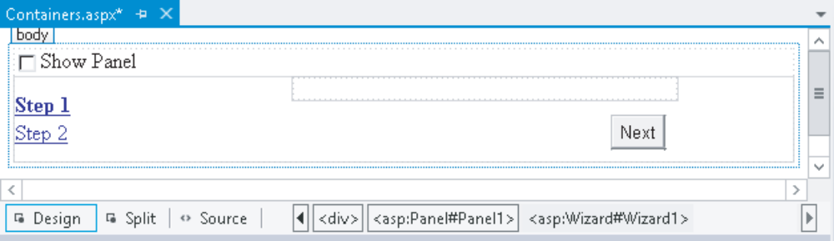
Figure 5

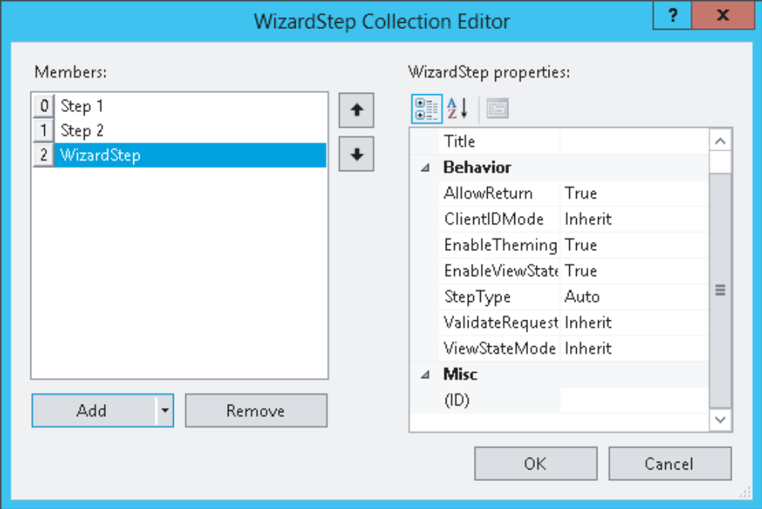
Figure 6

3. Click the first WizardStep labeled Step 1 in the Members list on the left and change its Title from Step 1 to About You. Set the Title of the other two steps to Favorite Language and Ready, respectively.
4. Change the StepType of the second step (now labeled Favorite Language) to Finish, and of the last step to Complete. You can leave the StepType of the fi rst step set to Auto. Click OK to close the WizardStep Collection Editor.
5. In Design View, click About You in the list at the left to make it the active step and drag a Label and a TextBox to the right side of the Wizard. You need to drag them inside the gray rectangle that’s in the upper-right corner of the Wizard, or the controls won’t end up inside the Wizard. Set the Text property of the Label to Type your name and change the ID of the TextBox to YourName. When you’re done, your Wizard looks like Figure 7.
6. Click the Favorite Language item in the list on the left to make it the active step. Add a DropDownList to the rectangle with the gray border on the right part of the wizard step. Rename the DropDownList by setting its ID to FavoriteLanguage. Open the Smart Tasks panel of the DropDownList control and choose Edit Items. Add the three items for C#, Visual Basic, and CSS, respectively. You should end up with the following code for the second step:
</asp:WizardStep>
<asp:WizardStep runat="server" Title="Favorite Language" StepType="Finish">
<asp:DropDownList ID="FavoriteLanguage" runat="server">
<asp:ListItem>C#</asp:ListItem>
<asp:ListItem>Visual Basic</asp:ListItem>
<asp:ListItem>CSS</asp:ListItem>
</asp:DropDownList>
</asp:WizardStep>
<asp:WizardStep runat="server" StepType="Complete" Title="Ready">

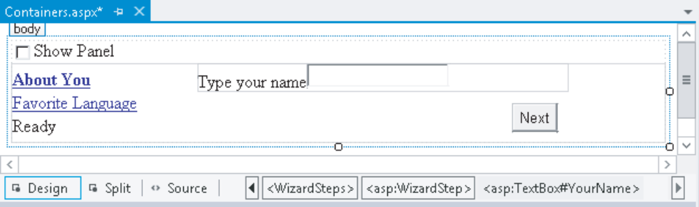
Figure 7

7. For the final step, switch to Markup View. If you try to switch to the last step in Design View, you may notice that the Wizard disappears. If that happens, switch to Markup View and set ActiveStepIndex to 0 again on the opening tag of the Wizard control. Inside the last WizardStep labeled Ready, drag a label control from the Toolbox and rename it by setting its ID to Result. Alternatively, inside the code for the last step, type the word label and then press Tab to execute a code snippet for inserting a Label. Then add the ID attribute manually.
8. Double-click the Wizard in Design View and add the following bolded code, which will be executed when the user clicks the Finish button on the last step of the wizard. If you’re having problems getting VS to create the correct code for you, as you see it in the next snippet, select the Wizard, press F4 to open up the control’s Properties Grid, and then click the button with the lightning bolt on it (the fourth button from the left on the toolbar of the Properties Grid), as shown in Figure 8. This part of the Properties Grid is often referred to as the Events tab of the Properties Grid. Locate and double-click

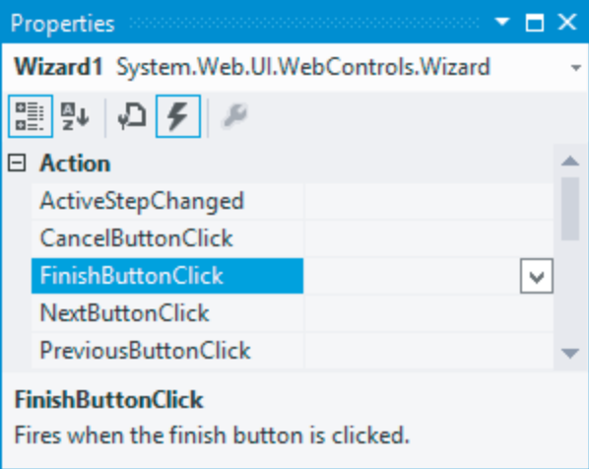
Figure 8

FinishButtonClick in the Action category. With both methods, you should end up with some code for Wizard1_FinishButtonClick that you need to extend with the following code:

Protected Sub Wizard1_FinishButtonClick(sender As Object,
e As WizardNavigationEventArgs) Handles Wizard1.FinishButtonClick
Result.Text = "Your name is " & YourName.Text
Result.Text &= "<br />Your favorite language is " &
FavoriteLanguage.SelectedValue
End Sub

9. Switch back to Design View and open the Properties Grid for the Wizard and make sure its ActiveStepIndex is set to 0. The designer remembers the last step you designed and stores the value in the ActiveStepIndex of the Wizard in Markup View. To make sure the Wizard starts on the first page, you should always set the ActiveStepIndex back to 0 (or click the first step in the Wizard control in Design View) before you save your changes and run the page.
10. Save all changes, close all open browser windows, and press Ctrl+F5 to open the page in the browser. Select the check box to make the Panel visible and enter your name on the first wizard page. Click Next and choose your favorite programming language. Notice how there’s now a Previous button available that enables you to go back to the first step of the wizard if you want to change your name. Instead of clicking the Next and Previous buttons, you can also click the links on the left of the wizard in the browser. When you click the Finish button, you’ll see the results of the information you entered in the wizard (see Figure 9).

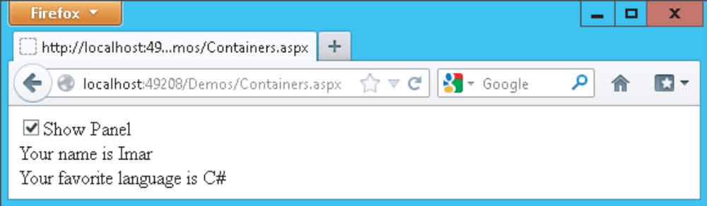
Figure 9

Q4) Create a web form that performs validation using Validation Controls
- Add a new Web Form named as validation_controls.aspx.

- Add a heading that says “Student Information”.

- Create a Table with 21 rows and 2 columns, and add the following controls in a Table.

Position | Control | ID Property | Text Property
Row (1), Column (1) | Label | - | Title
Row (1), Column (2) | DropDownList | ddlTitle | -
Row (1), Column (2) | RequiredFieldValidator | rfvTitle | *
Row (2), Column (1) | Label | - | First Name
Row (2), Column (2) | TextBox | txtFirstName | -
Row (2), Column (2) | RequiredFieldValidator | rfvFirstName | *
Row (3), Column (1) | Label | - | Last Name
Row (3), Column (2) | TextBox | txtLastName | -
Row (3), Column (2) | RequireFieldValidator | rfvLastName | *
Row (5), Column (1) | Label | - | Address
Row (5), Column (2) | TextBox | txtAddress | -
Row (6), Column (1) | Label | - | City
Row (6), Column (2) | TextBox | txtCity | -
Row (7), Column (1) | Label | - | State
Row (7), Column (2) | DropDownList | ddlState | -
Row (7), Column (2) | RequiredFieldValidator | rfvState | *
Row (8), Column (1) | Label | - | Postal Code
Row (8), Column (2) | TextBox | txtPostalCode | -
Row (8), Column (2) | RegularExpressionValidator | revPostalCode | *
Row (10), Column (1) | Label | - | Phone
Row (10), Column (2) | TextBox | txtPhone | -
Row (10), Column (2) | RegularExpressionValidator | revPhone | *
Row (11), Column (1) | Label | - | Enroll Date
Row (11), Column (2) | TextBox | txtEnrollDate | -
Row (11), Column (2) | CompareValidator | cvEnrollDate | *
Row (12), Column (1) | Label | - | Birth Date
Row (12), Column (2) | TextBox | txtBirthDate | -
Row (12), Column (2) | RequiredFieldValidator | rfvBirthDate | *
Row (13), Column (1) | Label | - | CGPA
Row (13), Column (2) | TextBox | txtCGPA | -
Row (13), Column (2) | RangeValidator | rvCGPA | *
Row (15), Column (1) | Button | btnSubmit | Submit
Row (17), Column (1) | Label | - | Bullet List
Row (17), Column (2) | ValidationSummary | - | -
Row (19), Column (1) | Label | - | Single Paragraph
Row (19), Column (2) | ValidationSummary | - | -
Row (21), Column (1) | Label | - | List
Row (21), Column (2) | ValidationSummary | - | -

- Add the members: Unknown, Mr., and Ms. to the DropDownList (ddlTitle). Add the members: Select…, states of Malaysia to the DropDownList (ddlState).

- Change the RequiredFieldValidator properties to the following settings.

RequiredFieldValidator | ControlToValidate | ErrorMessage | InitialValue
rfvTitle | ddlTitle | Select a title. | Unknown
rfvFirstName | txtFirstName | Enter first name. | -
rfvLastName | txtLastName | Enter last name. | -
rfvState | ddlState | Select a state. | Select…
rfvBirthDate | txtBirthDate | Enter birth date | -

- Change the RegularExpressionValidator properties to the following settings.

RegularExpressionValidator | ControlToValidate | ErrorMessage | ValidationExpress
revPostalCode | txtPostalCode | Enter a valid postal code. | [0-9][0-9][0-9][0-9][0-9]
revPhone | txtPhone | Enter a valid phone number. | [0-9][1-9][1-9]-[1-9][0-9][0-9][0-9][0-9][0-9][0-9]

- Change the CompareValidator properties to the following settings.
ControlToCompare: txtBirthDate
ControlToValidate: txtEnrollDate
ErrorMessage: Enroll date is greater than birth date.
Operator: GreaterThan
Type: Date

- Change the RangeValidator properties to the following settings.
ControlToValidate: txtCGPA
ErrorMessage: Enter a number between 0 and 4.
MaximumValue: 4
MinimumValue: 0
Type: Integer

- Chang ValidationSummary1 property to the following settings.
ShowMessageBox: true

- Chang ValidationSummary2 property to the following settings.
DisplayMode: SingleParagraph
ShowMessageBox: true

- Chang ValidationSummary3 property to the following settings.
DisplayMode: List
ShowMessageBox: true

- Right-click on the project and select Manage NuGet Packages. In the left panel of the dialog box that appears, click on NuGet Official Package Source. Next, use the box in the upper right to search for AspNet.ScriptManager.jQuery. Then, click on the Install button.
You Web site should look like similar as follows.
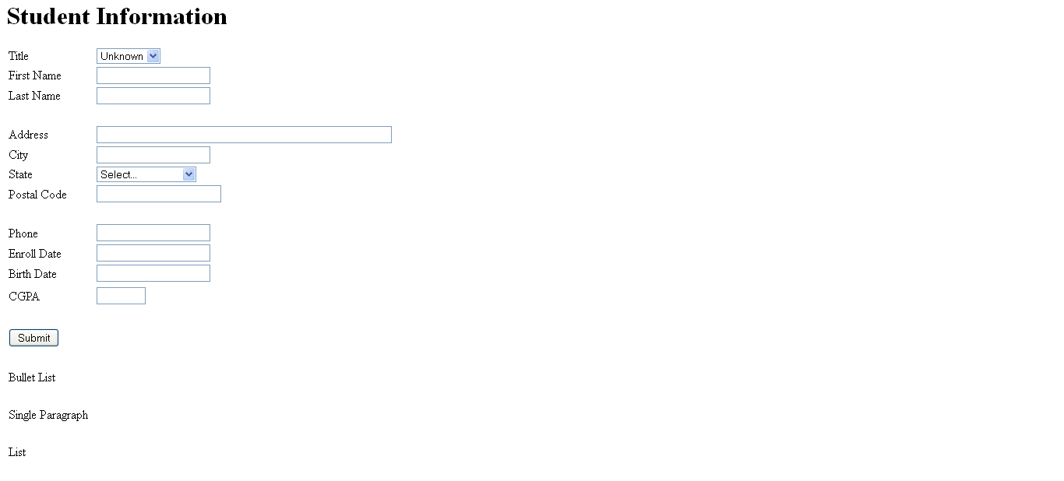
Figure 10: The layout of the student informaton

Part 2: To be done by yourself
Create the webform Room Reservation. Determine the best Web Server control to use for each of the field listed below, unless otherwise stated.

The information required are: Name, CheckInDate, CheckOutDate, Guests per Room, RoomType

Additional Information:
- CheckInDate is a DropDownList with values 30 days from current date.
- CheckOutDate is calculated based on CheckInDate and LengthOfStay
- 3 possible room types: Single, Twin Sharing and Double, only 1 may be selected
- Guests per Room: Single (1), Twin Sharing (2) and Double (3)
Determine and provide the markup for validation controls required.
- Name – required, in the format Surname, LastName.
- GuestsPerRoom – based on value in RoomType
Write the code-behind to populate CheckInDate during Page_Load

Write the code to determine CheckOutDate based on CheckInDate and LengthOfStay

GuestsPerRoom has a custom validator, write the code to ensure that the number of guests registered does not exceed the allowable number for that particular room.

GuestsPerRoom is a DropDownList and the webform contain a panel2 which is shown when GuestsPerRoom exceeds 1 for user to enter the names of other guests. How would you design your program to accomplish this? Your answer should include the code for creating the number of textboxes in panel2

